Peak Petroleum Industries Nigeria LTD

and

Equator Exploration Nigeria LTD

Offshore Nigeria Block OML 122

Bilabri D2

WELL TEST PROGRAM

Drilling Unit
Semisubmersible Bulford Dolphin

WellTest Procedure Prepared by:

Completion Engineer – Peak Petroleum – John Viscarde

Welltest Procedure Approved by:

Managing Director - Peak Petroleum Industries Nigeria – Dr. Ayodeji Oluokin

Project Director - Peak Petroleum Industries Nigeria – Glyn Evans

Managing Director - Equator Exploration LTD – Ken Seymour

Chief Operations Officer - Equator Exploration LTD – Philip Dimmock

Table of Contents
Section 1: Introduction

Section 2: Test Objectives / Basic Well Data

Section 3: DST Operation Summary
3.1 DST #1: C2 Horizontal Sands

Section 4: Well Preparation for DST Operations
4.1 Running 6 5/8” OD Reslink 225 Standalone Sand Screens
4.2 Displace SOBM with 10.1 CaCl filtered Brine

Section 5: DST #1: C2 Operation Procedure
5.1 General Running Procedure
5.2 Flow and Shut in Periods
5.3 Well Kill Procedure

Section 6: Temporary Abandon Procedure

Section 7: General Testing Guidelines

Section 8: General Flowing

Section 9: Well Kill Procedure

Appendix

1. Personnel Responsibilities
2. Safety Guidlines
3. Wellbore Schematic
4. BJ Screens
5. Halliburton Test String Components
6 Expro/Powerwell Landing String
7. Bulford Dolphin SS BOP Stack Layout
8. Expro / Powerwell Surface Test Spread

Section 1: Introduction

Test Objectives
The specific objectives of the C2 production test program for the Bilabri D2 consist of the following:
- Establish maximum sustainable flow at commercial rates.
- Obtain high quality samples for PVT/compositional analysis.
- Estimate Productivity Index (PI) / Inflow Performance.
- Determine completion efficiency (skin).
- Estimate reservoir permeability (radial k and if possible k_{v}/k_{h}).
- Access connected drainage area / presence of any faulting.

The first priority of the Production Test program is to ensure that all operations are carried out safely and efficiently, with due regard for safety of personnel and equipment and for protection of the environment.

Testing will be carried out in accordance with the following procedures:

Operations Procedures:
- Halliburton Drill Stem Testing Guidelines
- Expro / Powerwell guidelines for manual sampling and analysis of hydrocarbon fluids
- Peak/Equator Well Test Program

Contractor Reference Documents, Procedures, and Manuals :
- Dolphin Vessel Safety Case
- Dolphin Hazard Identification Report
- Dolphin Formal Safety Assessment including Quantitative Risk Assessment
- Dolphin Safety, Health & Environment Manual (incl. Permit to Work System)
- Dolphin Emergency Response Procedures
- Dolphin Well Control Manual
- Dolphin Marine Operations Manual
- Powerwell, and Halliburton Testing Field Operating Manuals
- Baker Atlas Pressure Control Manual

1. Without prejudicing emergency requirements, any deviation from this program which could have safety implications or could significantly affect the test objectives must be approved by Peak / Equator Joint Operating Team.
.
Any deviation from the program must be issued in writing and approval indicated by the signatures of the Peak / Equator Joint Operating Team prior to commencement of any activities covered by the program deviation. Minor procedural variations to the program may be approved offshore by the Peak Drilling Supervisor, Peak Well Test Engineer, or Dolphin OIM.

2. Ultimate responsibility for the safety of all personnel on board and for the security of the rig rests with the Dolphin OIM. All matters which could affect the safety of personnel or the rig must be discussed with him or with his appointed delegates, and close liaison between Dolphin, Peak, and Contractor personnel must continue at all times.

3. The Peak Drilling Supervisor is the senior authority offshore responsible for the execution of this program in a safe and sound manner, in accordance with relevant Peak/Equator procedures, government regulations, and relevant industry codes and standards.

4. The Peak Well Test Engineer reports to the Peak Drilling Supervisor offshore. The Peak Drilling Supervisor, or his designate, is responsible for the supervision of the activities and personnel covered by this program, though he may delegate responsibility for specific aspects of the program to the Peak Well Test Engineer.

5. Prior to the commencement of any new phase of operations the Peak Drilling Supervisor and the Peak Well Test Engineer will conduct a safety and operations briefing with relevant crew members.

6. All work to be carried out under this program will be carried out under the Dolphin Permit To Work System. For the duration of the production test phase, the Permit System shall be modified to require the Peak Drilling Supervisor to sign all permits (in addition to the Dolphin OIM).

7. Considering the complications associated with crude, initial flow of hydrocarbons to surface will not be undertaken at night.

8. In the event Hydrogen Sulphide (H₂S) levels above 20 ppm in the wellstream or above 10 ppm in the atmosphere are detected, the well will be shut in down-hole and at surface and the situation assessed with consideration for terminating testing operations.

Section 2: Test Objectives / Basic Well Data

Objective Formations / Test Strategy: C2 : Oil Sand
The S3 sidetrack is aimed to prove-up the oil potential of the C2 sand

Since the C1 sand was mainly gas bearing the well will be plugged back to 13 3/8” casing point at 1650 metres MD and subsequently sidetracked (S3) to the southeast as a horizontal producer in the C2 sand, that was found oil bearing in the Bilabri-1 and Deep-1 wells. Structural control for the C2 horizontal well is very good as the proposed sidetrack is located approximately between the Bilabri-1 and Bilabri Deep-1 well.

Primary Testing Objectives:
- to prove-up the oil reserves in the C 2 sand,
- to appraise the reservoir qualities of the C2 sand
- to establish an oil producer at the C2 sand
- to penetrate the producing reservoirs in an optimal position, with horizontal completions.

The well will be flow tested, to assess reservoir production performance.

During the flow testing of the well, pressure and production data will be gathered to simulate boundary conditions and well productivity.
Oil production from this well may be available from July 2007.

Reservoir specified testing equipment:
1. Running 6 5/8” OD Reslink 225 Standalone Sand Screens.
2. Downhole shut-in capability.
3. Downhole Gauges.
4. Surface PVT sampling

Reporting Requirements:
All reporting of test production data will be the responsibility of the Peak Well Test Engineer. The Test Engineer will provide well test data to be included in daily drilling report and organize collection of specific data pertaining to DST Operations.

Basic Well Test Data:
Well Name: Bilabri D2
Designation: Development Well
License: OML 122

Operator: Peak Petroleum Industries Nigeria LTD
Partner: Equator Exploration Nigeria LTD
Anticipated Spud Date: July 2006

Rig: Bulford Dolphin
Rig Contractor: Dolphin Drilling
Rig Type: Aker H3 Semisubmersible

Water Depth: 153m MSL
RKB to MSL: 25 meters

Proposed Surface Location: Lat: 04º 39’ 17.394” N
Long: 05º 04’ 46.574” E
X = 730,700 E
Y = 514,850 N

Projection: UTM Zone 31N
Spheroid: WGS 84
Datum: WGS 84
Type: Transverse Mercator
Central Meridian: 3.0E
Scale Factor: 0.9996
False Northing: 0.00 meters
False Easting: 500,000 meters
Zone 31

Objectives: S1 Pilot – Appraise Oil Rim in C1 Main Gas Sand
S2 Landing – Develop C1 Main Gas Sand
S3 Landing – Fall Back Option to Develop C2 Oil Sand

Casing Setting Depths (RKB): 30” @ 250m (72m below mudline)
20” @ 450m (272m below mudline)
13-3/8” @ 1650m TVD / 1650m MD
9-5/8” @ 2430m TVD / 3100m MD
8-1/2” Drain Hole TD 3600m MD – Screen Completion

Programmed Days: 43 days to drill S1 Pilot and S2 Horizontal Drain Hole
11 days to run screens and perform clean-up
54 days – Total Estimated Time

Total Depth: 2430m TVD / 3600m MD RKB

Section 3: DST Operation Summary
Following is a summary of well data for each of the 1 DST to be performed:

  - DST #1 – C2 Oil Sand

6 5/8” Reslink Standalone Screens + / - 500 meters

Expected Production: Oil
Estimated BHP: 3770 psig @ 2555m MD - Prior Dst Bilabri DX1

Completion Fluid: CaCl @ 10.1 ppg

Test Objectives:

1. Establish reservoir productivity

2. Acquire compositional and PVT samples

3. Assess connected drainage area / presence of any faulting

Test Sequence:

1. Run 6 5/8” Reslink Standalone Screens + / - 500 meters

2. Displace to Brine

3. Run DST tools

2. Clean up on increasing rate with a view to sand control (6 hrs)

3. Build up Period 1 for reservoir re-pressurization (6 hrs)

4. High Rate Flow Period (12 hrs)

5. Build up Period 2 (24 hrs)

Sampling Requirements:

Surface recombination samples will be taken as follows:

1. (3) separator liquid oil samples

2. (3) 20 liter separator gas samples

3. (2) drums of 160 liters each of dead liquids, 10 x 25liter containers

Surface Data Acquisition
Flow Parameter | Time Frequency
Pressure at the Flow Head | 15 Seconds
Pressure before Choke | 1 minute
Temperature before Choke | 1 minute
Pressure after Choke | 1 minute
Separator Pressure | 1 minute
Separator Temperature | 1 minute
Liquid Flow Rate | 1 minute
Gas Rate | 1 minute
Gauge Tank Level | 30 minutes
Annulus Pressure | 15 minutes
BSW / H₂S / CO₂ | As Frequently as possible
Surface Temperature | 1 hour

Subsurface Data Recording

Pressure and temperature will be measured with a frequency of every 5 seconds from 1 hour before to 6 hours after rate change, and otherwise with 1 minute frequency.

Section 4: Well Preparation for DST Operations

COMPLETION PROCEDURE RECOMMENDATION
This procedure assumes the completion fluid system is in place and wellbore clean up has been done. The completion plan for this well involves running and setting 6 5/8” screen on a retrievable seal bore packer in 9 5/8” casing. The well is to be DST as an oil producer with 4 1/2” 15.5# S-135 RTS-6 tubing string with 6” molded seals located in 9 5/8” retrievable seal bore packer.
Make Up and Running of Screen and Packer Assembly

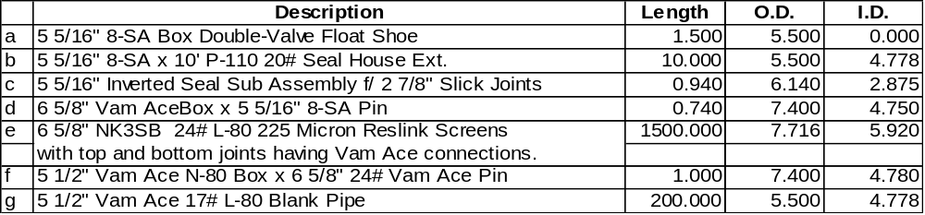MU and RIH with screen and blank assembly consisting of:
Note: Caliper and check tool connections, screen gauge, and record all lengths
Hang off screen and blank assembly with screen table and plate handling system.
Run 2 7/8” HCS washpipe and spaceout with stinger inside inverted seal sub above washdown shoe.

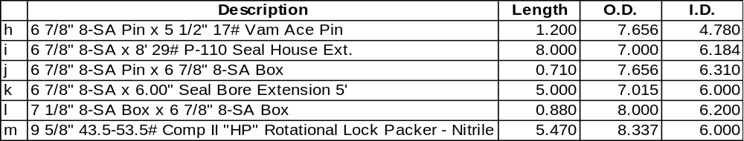PU BJ Services Comp-Set II HP Packer assembly consisting of:

Connect screen and blank assembly to packer assembly. Also connect the packer assembly to workstring and RIH with entire assembly slowly.
Notes:
Ensure all shear pins are in position and the setting sleeve connections are tight. Caliper and check tool connections, and record all lengths.
Handle packer with care, flush the ID with water to ensure nothing is obstructing the ID. Drift workstring while tripping in the hole and have only one drift on the rig floor and do not rabbit any tubing over rotary table. If necessary, sparingly use dope on the work string, pin ends only. Torque all connections to the recommended torque.
Always cover the hole whenever working above the rotary table.

NOTE : Drillpipe, screen and wash pipe tally to be prepared by BJ representative and reviewed by Peak Drilling Supervisor, Dolphin toolpusher and Peak Welltest Engineer. Prior to Picking up Screen assemblies, ensure that 2 painted joints are in the work string such that they will be across the BOP rams when at Packer setting depth. The rams will be functioned thereby marking the joints. This will be used for calculating spaceout for the subsesa tree and also stickup ( 4 meters) for the flowhead.

Prior to setting packer, BOPs will be functioned, and a mark using index line ( note tide ) taken with string in neutral position. The string length will be calculated from this mark to the top of the packer. BJ to review and supervise the tally.

4.1 Running 6-5/8” OD Reslink 225 Micron Standalone Sand Screen assembly:

General Notes:
- Ensure the shakers are screened up to 265 mesh and the hole has been circulated and conditioned at the 9-5/8” shoe.

- Screen fluid compatibility test (in appendix) will be performed as per procedure with 6-5/8” screen gauge (225 micron) prior to running screens.

- Ensure the 9-5/8” casing has been pressure tested to 4000 psi and SOBM has been filtered with 265 mesh shaker screens, before picking up Horizontal Open Hole Screen assembly.

Completion Screen Running Procedure:
- Make wiper trip with recommended BHA from BHI Directional Driller after running VSP Log in 8-1/2” horizontal drain hole. Displace open hole to Base Oil from toe to 9-5/8” shoe. Pull back to 9-5/8” shoe. Flow check well for 1 hour to ensure well is static.

- Circulate and condition SOBM to ensure that SOBM has been filtered through 265 mesh shaker screens and perform screen compatibility test procedure.

- Rig up casing handling equipment for 6-5/8” Reslink screens. Screens will be run without centralizers. RIH using correct elevators for screen size.

- Pick up +/-500 meters of 6-5/8” OD 225 micron Reslink Screens with NK3SB box x pin and approximately 150’ – 200’ of 5-1/2” blank pipe. Top and Bottom screen joints are cut to have Vam Ace Box on top connection and Vam Ace Pin on bottom joint. Hang off screen and blank assembly with screen table and plate handling system.
Torque requirements for 6-5/8” NK3SB
Min = 6720
Opt = 8400
Max = 10080
Torque requirements for 6-5/8” Vam Ace
Min = 6510
Opt = 7230
Max = 7950
Torque requirements for 5-1/2” Vam Ace
Min = 4560
Opt = 5060
Max = 5560

- Pick up washpipe according to BJ representative. Connect screen and blank assembly to packer assembly. Also connect the packer assembly to workstring and RIH with entire assembly on 5” workstring. Make up the BJ 9-5/8”, 43.5-53.5#/ft, Comp II HP Packer Assemby as per BJ Service Engineer.

Note:
- Ensure all shear pins are in position and the setting sleeve connections are tight. Caliper and check tool connections and record all lengths with ID and OD.
- Handle packer with care, flush the ID with water to ensure nothing is obstructing the ID. Drift 5” drill pipe workstring to 2.75” ID while tripping in the hole and have one drift on the rig floor and do not rabbit any tubing over rotary table. If necessary, sparingly use dope on the work string, pin ends only.
- Always cover the hole whenever working above the rotary table.
- Ball that will be dropped to set production packer is 2.25” OD steel ball.
- Break circulation every 10 stands to ensure the drill pipe is continuing to fill. Packer can be released from the running tool if a 1200 to 1500 psi differential is created in favor of the annulus side.

- RIH workstring, Lower the system into the wellbore on 5” work string and break circulation before continuing into the well. RIH at a rate not to exceed 1 stand/90 seconds. Rabbit drill pipe while RIH. Before running out 9-5/8” shoe - take PU and SO weights. Break circulation with +/- 5 bbls to ensure ball seat is clear of debris.
Note: Maximum torque for BJ Packer System = 7300 ft lbs if rotating required.

- Run into open hole with 6-5/8” Screen Assembly to end of toe. Tag TD to ensure pipe tally. Space out to be +/-5 feet off bottom. Ensure space out does not put packer setting in collar of 9-5/8” casing. Space out accordingly.

- Proceed to set the Comp II Packer as per BJ Service Engineer:
- With the packer spaced out and the work string full, drop 2.25” steel ball. Fall rate expected to be 250 feet/min. If the ball has to pumped down to the seat, maintain 1 to 2 bpm – not to exceed 3 bpm and 500 psi surface pressure. PACKER SETTING PRESSURE = 900 psi.
  - Check the OD of the setting ball.
  - Drop ball down drill pipe only.
  - Ball will fall at 4 minutes/1000’
  - Monitor annulus on trip tank and monitor well for losses.
- With ball on seat, pressure up on tubing slowly to 2600 psi in 500 psi increments. At +/-1000 psi the setting sleeve has been activated and the packer will start to set. At +/-2600 psi the setting sleeve on the setting tool has been sheared and the packer set. Bleed work string to 0 psi. Pull tension of 10000 – 15000 lbs on the packer to test the slips are holding.
Note: The packer can not be re-engaged after releasing from it. In an emergency, the SRTS Non Rotational Annulus tool can be released from
the packer with 7 to 9 turns to the right. Place the work string in neutral
or slight tension when releasing with rotation.
- Position work string with neutral weight,mark pipe using the Index line. This reference is critical for calculating spaceout. and test packer with the cement unit by pressuring up and testing the annulus to 1500 psi for 10 minutes. At 1500 psi, the service tool will be released from the packer. Bleed the annulus to 0 psi.
- Snap out of packer and pick up +/-8 feet. Pressure the drill pipe to 2600 psi (2200 psi to 3000 psi range) to blow the ball seat, which will allow circulation through the work string. After shearing the ball seat, bleed the workstring to 0 psi.

- Locate end of packer setting tool +/-5 feet above the packer. Establish circulation rates. Mix and pump displacement pill and filtered 10.0 ppg NaCL Brine (depending on actual RCI Pressures taken in S1 Pilot Hole).
  - 20 bbls of Base Oil
  - 50 bbls of Caustic Pill
  - 100 bbls of MagnaDirt Pill (2.1 gallon/bbl CWAL in filtered SW)
  - 50 bbls of High Vis (5 ppb CWAL Xanpol-P in filtered SW)

- Circulate out to 10.1 CaCL filtered brine. Repeat above process until well clean to +/-150 NTU clarity.

- POOH with packer running and service tools. Lay down same. Lay out washpipe, work string. Note Depth BOP ram marks on pipe. Continue tally to calculate proper depth top of packer. BJ serviceman to verify.

Section 5: DST #1: C2 Operation Procedure

Reslink Standalone Screens

Expected Production: Oil

5.1 General Running Procedure:
- Install the bottom hole pressure gauges in their carriers with recording set up as directed by the Peak Well Test Engineer. Pressure test the carriers on deck to 5000 psig after gauges have been installed.

- Pick up and make up the DST tools , gauge carriers and 4-1/2”, 12.75#/ft, L-80, CS Hydril tubing under the direction of the Halliburton DST tools supervisor. Refer to Appendix #4 for details of the of the test string configuration.
Note:
a. Drift all components to 1-7/8” ID minimum.
b. Accurately measure and record all tool lengths.
c. Use Best-O-Life 2000 thread compound for all tubing/test string connections.
d. Use a safety clamp around all connections made on Halliburton tools.

- Run the Select Tester Valve in the lock open position to permit pressure testing of the test string against the Tubing String Testing Valve (TST). The Select Tester Valve is the downhole shut in valve. The valve can be unlocked with the application of 2300 psi annulus pressure. After unlocking the valve, the valve can be held open with application of 1000 psi annulus pressure.

- The OMNI Circulating Valve should be run in the well test position. The Omni Circulating Valve is used for circulating or reversing. The ball valve is to be open on the tubing side and the circulating valve closed to the annulus.

- Make up the Drain Valve and the RD Safety Circulating Valve. This RD Safety Valve is a one time rupture disk operated valve that is run with the valve open and the circulating ports closed. Rupture disk is to be set for rupture with the application of 3500 psi annulus pressure. When rupture disk pressure is reached, the valve closes and circulating ports open.

- Install the stabbing valve. Close the stabbing valve and pressure test from the cement unit to 5000 psig for 5 minutes. Open the stabbing valve and pressure test the string to 5000 psig against the TST. Record the pressure test for 10 minutes on the cement unit chart.

- Continue to run in hole with the 4-1/2”, 12.75#/ft, L-80, CS Hydril , 4-1/2”, 15.5# PH6 tubing until half of the necessary tubing length as calculated from the pipe tally has been run. Pressure test the tubing string to 5000 psig against the TST Valve. Record the pressure test for 10 minutes on the cement unit chart.

- The TST valve will allow the string to fill as the DST tools are run in.

- Ensure the BOP rams are open. While pressure testing, monitor for annular returns which would indicate a leak in the downhole components.

- Continue to run in hole with the 4-1/2” PH-6 tubing until all necessary tubing as calculated from the tally has been run. Makeup spare fluted hanger and continue RIH. Land test string into subsea wellhead.
Note:
a. Ensure no right hand rotation of string
b. Monitor brine displacement closely
c. Use correct size tubing stabbing guides
d. Clean and inspect threads
e. Ensure nothing drops in the string

- Pick up the SSTT assembly with a crossover to 4-1/2” PH-6 tubing below the fluted hanger and make up onto the tubing. Any differences in length of this crossover and fluted hanger to those used for the dummy run should be noted.

- With the SSTT in the rotary table, perform a function check of the unlatch and relatch mechanism. Perform pressure test of the control hoses.

- Run in hole on the 4-1/2” PH6 landing string, including the lubricator valve which must be run in the open position and located a minimum of 30 meters below riser slip joint.

- Pick up CTU lifting frame and flowhead. Sting into Production screen packer, noting when seals engage packer bore. Slack off 4 meters.

- Land fluted hanger in wellhead. Connect kill and flow coflexip hoses.

- Prepare to pressure test the landing string, flowhead, and surface flowlines against choke manifold and lubricator ball valve to 5000 psi using the BJ cementing unit

- Pressure test the landing string and surface equipment to 5000 psig against the lubricator valve. Record the pressure test for 10 minutes on the cement unit chart. Rams must be open during the pressure test. Bleed off pressure and open the lubricator valve.

- Check that SSTT and lubricator valves are in the open position. Ensure that the master valve on the STT is open . Confirm the compensator is stroked open and compensating with the landing string in tension.

- Ensure the data acquisition system is recording and being monitored.

- Connect the Expro / Powerwell Emergency Shut Down system and function test from three remote stations. Record closure times. Prepare to hold safety meeting with rig crews on correct operation of ESD system.

- Ensure all personnel who will be involved on deck during the test, witness the demonstration and understand the mode of operation of the ESD system. Also ensure personnel on tour change are briefed on correct operation of the ESD system.

- Close the LPRs. Pressure up the annulus to 1000 psig for 10 minutes. This will permanently shear open the TST valve and will also check packer seal integrity.

- Pressure up annulus to 2300 psig to cycle Select Tester Valve out of lock-open position. Bleed off annulus pressure to close the Select Tester Valve. The OMNI will cycle to test position.

- Pressure test the BHA, Test String, Landing String, and the Surface Equipment against the Select Tester Valve and the Choke manifold to 5000 psig for 10 minutes using the BJ cement unit.

- Commence filling the gauge tank with 50 bbls of diesel to use as an ignition source for the auxiliary diesel flare.

- Cycle the annulus pressure as directed by the Halliburton DST supervisor to place the OMNI in the circulating position (circulating ports open, ball closed).

- Displace tubing to diesel to ensure well is 500 psi underbalanced as per Peak Well Test Engineer. Do not over displace diesel into annulus.

- Re-cycle OMNI to well test position by pressuring up annulus to 1000 psi for 1 minute and bleed pressure off repeating this cycling sequence to cycle the valve. On the last cycle before welltest, pressure up the annulus to 2300 psi and hold for 15 minutes. Bleed pressure to zero and choke manifold. Wait for 15 minutes before any further application of annulus pressure.

- Ensure everything is open to the choke manifold. Check all valves and gauges on annulus to ensure that pressures are accurately monitored. Ensure the watches for all Operators are synchronized with the Powerwell SCAN Computer.

5.2 General Flowing Procedure:
1. Perform the following checklist:
a. Wait on daylight if necessary. Hold pre-flow safety meeting.
b. Ensure that the following steps are implemented prior to flowing the well.
c. Ensure personnel are familiar with line rupture and leak response procedures.
d. Ensure personnel are aware of responsibilities as defined in Appendix 1.
e. The Safety Guidelines as defined in Appendix 2 are adhered to.
f. Surface Equipment has been installed as per Appendix 5.
g. Emergency Shut Down System has been installed and function tested.
h. Surface equipment pressure tests have been performed properly.
i. Powerwell Data Acquisition system is functioning properly.
j. Air compressors are running.
k. Sufficient kill fluids are available in mud pits.
l. Burner pilot lights are burning and the water deluge system is operational.
m. Advise work boats and the aviation shore base that testing operations are
about to commence. Boats to remain up wind of the proposed burner.
n. Advise Peak Base Manager that the well testing and flaring are imminent so
that necessary notification to government bodies can be made.
o. Radio Operator to inform Nigierian Authorities that flaring will occur in the
next 6 hours.
p. Make an announcement over the rig PA system that testing operations are
about to commence and hold all necessary safety briefings with crews.
q. The separator should be by passed and the well lined up to the gas flare.
r. Walk and inspect all lines.
s. Radios are checked and functioning properly with supervisors.
t. Fire extinguishers will be posted at the tank site.

2. Confirm all test valves are lined up correctly as follows:
- STT Master Valve Open
- STT Swab Valve Closed
- STT Flow Wing Valve Open
- STT Kill Wing Valve Closed
- Lubricator Valve Open
- SSTT Open
- Upstream Choke Manifold Closed

3. Ensure BOP stack is lined up with the LPR closed and lower inlet inner and outer failsafes open. While shut in at the choke manifold, pressure up the annulus to 1000 psi to open the Select Tester Valve. Maintain 1000 psi annulus pressure to keep the Select Tester valve open. Pressure up the tubing to required psi to activate the TCP gun firing head. Hold the tubing pressure for 1 minute and bleed off to zero psig to establish the under -balance condition prior to detonation. Observe for indication of gun firing downhole.

5.3 Flow and Shut in Periods:
- Open well on 12/64” choke. Exercise extreme caution when beaning up the well.
Note:
a. Monitor THP.
b. Note time of first hydrocarbons to surface.
c. Check for H₂S and C0₂ in well stream.
d. Peak Well Test Engineer will determine choke sizes, flow and build-up periods.

- Begin chemical injection at the choke manifold, and at the subsea test tree. Gradually increase choke to approximately 48/64”, constantly observing for sand production from the shake outs at the choke manifold. Timing and sizing of choke will be determined by well performance. Maintain choke manifold pressures in critical flow regime. Estimated flowing period 12 – 24 hours depending on well cleanup.

- Clean up on an appropriate choke size (~ 48/64” choke) until the well is reasonably clean, i.e. stable BS&W with low water salinity and WHP. Once a reasonably stable flow (as determined by the Peak Well Test Engineer) has been achieved on the 48/64” adjustable choke, reservoir fluids are burning cleanly, switch to 48/64" fixed choke. Continue the clean-up on this choke size. Continue to monitor WHP, BS&W and produced water salinity. Bypass flow thru the steam exchanger. Once BS&W shows absence of solids and a reasonably stable water cut, , switch the flow through the separator. Ensure that separator levels are monitored closely during flow periods, particularly after bean ups, to ensure no liquid slugs flood the separator. Constantly monitor heater temperature and observe for possible hydrates forming in the flowlines. Check chemical injection is functioning efficiently.

- Bleed off the annulus pressure to shut the well in at the Select Tester Valve for the Initial Build-Up. The objective of the initial build-up is to establish reservoir equilibrium prior to embarking on the main flow and to establish initial reservoir pressure under testing conditions.
Note: Shut-in well at Select tester valve bottom hole for Initial build-up. ( 12 hours)

- Shut in at the choke manifold once closure of the Select Tester Valve is confirmed and observe the wellhead pressure to confirm the Select Tester Valve is sealing (do not bleed off WHP more than 100 to 200 psig).

- Pressure up the annulus to 1000 psig to open the Select Tester Valve for the Main Flow rate. Open well at choke manifold on 16/64” adjustable choke slowly increase the choke gradually (over about 15 minutes) until the well is stable on a reasonably large choke size (48/64”) and maintain this choke size until WHP, BSW and Separator conditions are stable. Switch to a fixed choke once the Peak Well Test Engineer is satisfied with flow conditions on this choke size. Pass through the separator as soon as flow has been switched to the fixed choke and stabilize separator conditions. Bean up as appropriate. Bean up depending on WHP and flow response. Maintain critical flow across the choke manifold. Main objective is to establish a stable and sufficiently high gas rate, followed by a sufficiently long build-up period. Note that the highest gas rate will be demonstrated during the final multi-rate flow period for the gas test.

- Bleed off the annulus pressure to shut the well in at the Select Tester Valve for the Second Build-Up. Shut in at the choke manifold once Select Tester Valve closure is confirmed and observe the wellhead pressure to confirm the Select Tester Valve is sealing. Estimated time 24 hours.

- Do not bleed off the tubing pressure by more than 100 - 200 psig to minimise the differential pressure when re-opening the test valve.

- Pressure up the annulus to 1000 psig to open the Select Tester Valve for the Main Flow rate. Multi rate flow test will be conducted. Based on the cleanup rates and the high rate obtained in the previous flow rate, section of 3 fixed beans can be performed. The multi-rate will be used to determine absolute open flow potential (AOF) 3 rates @ 6 hours each.

- Open well at choke manifold on 16/64” adjustable choke slowly increase the choke gradually (over about 15 minutes) until the well is stable on a the first multi rate.
- PVT Sampling – 3 x 20 liter gas, 3 pressurized condensate
- 2 dead condensate, 2 water samples

- Maintain this choke size until WHP, BSW and Separator conditions are stable. Switch to the fixed choke once the Peak Well Test Engineer is satisfied with flow conditions on this choke size. Pass through the separator as soon as flow has been switched to the fixed choke and stabilize separator conditions. Commence the multi rate flow test. After the allotted time, approximately 6 hours, conduct the second multi rate, followed by the third and highest multi rate. Maintain flow across the choke manifold. Estimated flow period 18 hours minimum.

5.4 Well Kill Procedure:

Note : Kill fluid volumes and pump pressures are to be determined by the Peak Drilling Supervisor in conjunction with the Peak Well Test Engineer. Ensure all crossovers to stabbing valves are available on rig floor and ensure that Indirect Heater is functional prior to reversing out.

- Bleed off string above Select Tester Valve through choke manifold. Close choke manifold.

- Cycle the OMNI to reverse circulate position. Open the choke manifold and reverse circulate 2 string volumes to confirm no gas/hydrocarbons inside tubing.

- Cycle OMNI to well-test position. Cycle the Select Tester Valve to hold-open position.

- Unsting from packer. Circulate conventionally 1.5 times bottoms up carefully monitoring gas levels and pit volume changes. If hydrocarbons are detected, close BOP and circulate through drilling choke as required.

- Perform a 15 minute flow check. Flush the flowhead and surface lines.

- Breakout and laydown the flowhead, and Coflexip hoses.

- Pull out of hole with the landing string, service breaking the assemblies as required and laying down the landing string tubing. Monitor trip tank while POOH.

- Pull out of the hole with the DST string observing normal tripping procedures. Service break and lay down test tools and gauge carriers.

- Continue with Abandonment program as per drilling program.

Note :
All water produced in the separator during the test will be transferred to the surge tank prior to flaring. No water is to be dumped directly overboard. There shall be no flaring of water without visual observation.

The driller and a Halliburton DST tool technician must be on the rig floor at all times. The annulus pressure is to be continuously monitored and recorded on a chart recorder. Pressure is to be bled off as required to maintain the correct annulus surface pressure for tool operation. All pressure bleed off's are to be recorded.

Section 6: Temporary Abandonment

6.1 General Abandonment Procedure:

To Be Supplied by Drilling

Section 7: General Testing Guidelines

7.1 Overview of Surface Test Facilities provided by Expro / Powerwell
- Steam Exchanger heater downstream of the choke manifold and up-stream of separator.
- Instrumentation, sight glasses, shrinkage tester, oil sampling line.
- Burners modified for green burning.

7.2 Overview of the Test String provided by Halliburton
- Down-hole flow control will be achieved using annulus pressure-operated DST tools
- The main test string will be 4-1/2” PH-6 production tubing.
- A retrievable packer will be utilised.

7.3 Other Features of the Down-hole Test String Design
- Reservoir pressure data acquisition will be from Halliburton's shear quartz gauges located beneath the tester valve. These gauges will be located as deep as possible in the test string.
- The Select Tester Valve incorporates a “lock-open” feature to provide additional versatility. This will provide the bypass and can also be used during the well kill process.
- Pressure testing of the string will be against a separate Tubing String Test Valve (TST) located as low as possible in the string.
- The OMNI re-closable circulating valve will be the primary method of circulating with system redundancy provided by a single-shot "rupture-disc" circulating valve (RD Valve).
- A fail-safe sub-sea test tree (SSTT) will be run and landed in the sub-sea wellhead to provide sub-surface safety ,injection of chemicals to prevent hydrates and to allow safe unlatching of the landing string in case of emergency.
- The landing string will consist of 4-1/2”, 15.5 ppf, L-80 PH6 tubing.
- Slip Joints will be run to compensate for tubing expansion / contraction.

7.4 Test Equipment Preparation - General

The majority of test equipment preparation, testing and inspection will be conducted at the various contractor bases in Port Harcourt.

Testing and inspection procedures will be as per the contractors’ standard operating procedures and will be controlled and, where required, witnessed by the Peak Well Test Engineer.

The Permit To Work (PTW) system and WSHA (JSA, JHA) shall be used prior to performing any potentially hazardous activities.

The following sections outline the equipment preparation to be carried out on site.
Note that as the test under consideration requires non-conventional rig-up, the overall operations may require more time than normal.

7.5 Surface Test Equipment

- Rig up surface equipment and flow lines as per Appendix #5, Surface Equipment Layout Schematic.
- Pressure test according to the recommended Powewell Pressure testing Schedules.
- Perform calibration checks on all recorders, meters and gauges, in particular the differential pressure recorder and liquid flow meters.
- Pressure test the Surface Test Tree (STT) assembly on the deck to 5,000 psig against the master valve from below, against the swab, flow wing and kill wing valves from below, and externally against the kill wing valve.
- Make up a single of 4 1/2” PH6 landing string tubing below the flowhead. Drift the flowhead and single to 2.125”. Measure the length of this single.
- Function test the ESD devices.
- Connect and function test the indirect heater and air compressors.

7.6 DST Tools

- Make up test string into suitable sub assemblies.
- Drift all test string components to a minimum of 2.125” with an API drift provided by Halliburton.
- Pressure and function test the tools to 5,000 psig as per standard contractor procedures.
- Prepare a running list with all critical dimensions and operating pressures.
- Prepare a completion diagram with the dimensions, volumes, and depths of each string component.
- Calculations and pressure/function tests to be checked and signed off by the Peak Well Test Engineer, and records compiled for end of test report.

A number of down-hole tools are annulus pressure operated. The pressures required to operate these are given below :
Tool | Operating Press psig | Delay Time (Minutes)
SELECT | 1000 psig (to open)  2300 psig (to lock open) | 10
OMNI | 1000 psig | 1 (at all positions)
RD Circulating Valve | 3950 psig | N/A
Tubing Tester | 1000 psig | N/A

Notes:
- Delay time is the period to be allowed between successive tool operations.
- General Tubing Test Pressure will be 5,000 psig.
- Casing Test Pressure will be 4,000 psig.
- The OMNI valve cycle positions are shown in Appendix 7.

7.7 SUB-SEA ASSEMBLY

- Pressure test the SSTT on the deck to 5000 psig from below against both valves and perform a full body pressure test.
- Pressure test the lubricator ball valve from above and below to 5000 psig and perform a full body pressure test.
- Drift all assemblies to at least 2.125”.

7.8 GAUGES AND DATA RECORDING

- Program the downhole memory gauges as appropriate for recording the relevant downhole pressure data. Set a suitable slow sampling rate (1 min) on the gauges to avoid wasting memory capacity by recording excessive amounts of data while running in.
- Check batteries are new and appropriately specified for the job.
- Check gauge calibrations.
- Ensure the Well Test Data Acquisition system is functional and acquiring data prior to setting packer.
- Gauges will be run as follows:
(4 ) SQ-400 gauges in the gauge carrier below the Select Tester Valve.

7.9 TEST EQUIPMENT DOCUMENTATION TRACEABILITY AND QC

- All items to be run in hole will be inspected and pressure-tested prior to running, as per above procedures.
- All equipment delivered to the rig for downhole or surface use must be accompanied by current valid inspection certificates (less than 6 months old). These shall be recorded and kept in a QC documentation file by the Test Engineer.
- All onboard pressure testing must be witnessed and signed off by the Peak Well Test Engineer or Drilling Supervisor. Chart recorder records will be kept on file in the QC documentation file.
- Copies of critical pressure, space out and tally calculations will be kept in the QC file.
- Calculations of operating pressures and space out must be reviewed by at least 2 competent persons.

7.10 TUBULARS

4-1/2”, 15.5 ppf, L-80 PH-6 Production Tubing
4-1/2”, 12.75 ppf, L-80 CS Hydril Production Tubing

- When tubing arrives on location remove thread protectors, clean threads and inspect for damage. Reject any damaged joints on the basis of visual inspection.
- Number and measure the joints and compile an accurate tally accounting for make-up loss. This will be done by the Peak Drilling Supervisor.
- Drift both the 4-1/2” PH-6 , CS Hydril tubing using a API drift.
- Ensure the figures for correct make-up torques are available.

7.11 BOP STACK TESTS
Minimum requirements for BOP stack tests.

Item | Test Pressure
BOP rams | 200 psig /  5,000 psig
Annular | 200 psig /  3,500 psig
Casing, Shear Rams | 200 psig /  5,000 psig
Choke and kill manifold | 200 psig /  4,000 psig
If necessary, confirm the depth of the wear bushing during the BOP stack test by marking the drill pipe at the rotary table using a Reference Line to the slip joint and measuring out of the hole. Correct depth for tide variations.

.
- General Check List:
- Wait on daylight if necessary. Hold pre-flow safety meeting.
- Ensure that the following steps are implemented prior to flowing the well:
- Hold safety meeting and review JSAs relating to the operations to follow.
- Personnel are familiar Line Rupture and Leak Response Procedures.
- Personnel are aware of their responsibilities as defined in Appendix 1.
- The Safety Guidelines as defined in Appendix 2 are adhered to.
- Surface equipment has been installed as per Appendix 5.
- Emergency Shut Down system has been installed and function tested.
- Surface equipment pressure tests have been conducted as per Appendix 3.
- Data acquisition system is functioning.
- Air compressors are running.
- Sufficient kill fluids available.
- Burner pilot lights are lit and the water deluge system is operational.
- Advise work boats and the aviation shore base that testing operations are about to commence. Boats to remain up-wind of the proposed burner boom.
- Advise Peak Base Manager that well testing and flaring are imminent so that necessary notification to government bodies can be made.
- Radio Operator to inform Maritime Safety Authority that flaring will occur in next 6 hours.
- Make an announcement over the PA that testing operations are about to commence and hold all necessary safety briefings with rig crews.
- The separator should be by-passed and the well lined up to the gas flare.
- Walk and inspect all lines.
- Radios are checked and functioning.

- Confirm all valves are in correct position as follows:
- Flowhead Master Valve Open
- Swab Valve Closed
- Flow Wing Valve Open
- Kill Wing Valve Closed
- Lubricator Valve Open
- SubSea tree Open
- Upstream Choke Manifold Closed

- Fire up the steam generator and ensure it is ready for operation.

Section 8: General Flowing Guidelines

1. Ensure the following final preparations have been made:
a. The wind direction is acceptable for flaring on the present vessel heading.
b. No "Hot Work Permits" are outstanding.
c. The standby boat, helicopter base, and Lagos Office have been notified that the well is about to be perforated.
d. A general rig announcement has been made that the well is about to be perforated.
e. All personnel know where their stations are and their duties.
f. The STT flowline valve remote shut-in systems have been tested.
g. All surface production test equipment has been pressure tested and all piping/valving is properly aligned.
h. Preparations have been made to inject glycol as required and appropriate protective gear is available for operators.
2. Conduct a safety meeting with relevant crew members.
3. Close STT swab valve. Close choke manifold inlet valve. Open STT kill valve, master valve, and flowline valves.
- Initial Flow and Build-up: An initial cleanup flow will be performed and times will be dependent on reservoir response. An initial shut-in will be conducted to obtain reservoir pressure. The well flow rates will be gradually increased as not to induce large drawdowns that could initiate sand production. The rates will be dependent on reservoir response. Testing times will be determined by the Peak Well Test Engineer in agreement with Peak/Equator Joint Operating Team. All shutins will be downhole using the the Select Tester Valve by bleeding off annulus pressure.
5. Main Flow: The well will be produced on gradually increasing choke sizes, with the flow rate increasing as per Peak Well Test Engineer. The flow rates and times will be dependent on reservoir response. Main concern is no sand production, and flow lengths sufficient to investigate boundaries. Testing times will be determined by the Peak Well Test Engineer in agreement with Peak/Equator Joint Operating Team. Surface PVT sampling will be taken.
6. Main Shut-In: Close the Select Tester Valve by bleeding the annulus pressure to 0 psi. Bleed down surface tubing pressure by several 100 psi, to verify that the Select Tester Valve has closed. Shut in choke manifold. Pump out the gauge tanks to the flare - use diesel injection to obtain a good burn if necessary. Shut down compressors and water curtain. Monitor tubing and annulus pressure.

Section 9: Well Kill Procedure
1. Bleed off tubing string above Select Tester Valve through choke manifold. Close choke manifold.
2. Cycle the OMNI valve to reverse circulation position. Open the choke manifold and revers circulate 2 string volumes to confirm no diesel/hydrocarbons inside tubing.
3. Cycle OMNI valve to well-test position. Cycle the Select Tester Valve to hold-open position.
4. Unsting from the packer and space out across stack. Circulate conventionally 1.5 times bottoms up, carefully monitoring gas levels and pit volume changes. If hydrocarbons are detected, close BOP and circulate through drilling choke as required to kill well.
5. Perform a 15 minute flow check. Flush the STT and surface lines.
6. Break out and lay down the STT, and Coflexip Hoses.
7. Pull out of hole with the landing string, service breaking the assemblies as required and laying down the landing string tubing. Monitor trip tank while POOH to ensure proper hole fill.
8. Pull out of the hole with the DST string observing normal tripping procedures. Service break and lay down test tools and gauge carriers.
9. Continue with plug back of zone as dictated in the well suspension and plug back procedures.

APPENDIX

APPENDIX 1
Personnel Responsibilities

1.1 Peak Drilling Supervisor
Directly responsible for all operations. May delegate responsibility to Peak Well Test Engineer during flow & shut-in periods.

1. Ensure operations are professionally managed in a manner that protects the environment, comply with all government regulations, and follow Company policy.
2. Review with key personnel, contingency plans for potential testing emergencies.
3. Co-ordinate the overall conduct of the production test and assign personnel responsibilities.
4. Liase with the Dolphin OIM to ensure that all safety preparations are made.
5. Hold a safety meeting with all personnel involved in testing at an opportune time prior to running the test string and assign personnel responsibilities.
6. Emphasise that all personnel aboard the rig are authorised to shut-in the well using the ESD, if an incident occurs that poses a potentially serious safety hazard to the rig and personnel.
7. Ensure the Permit to Work System is utilized for all test operations. Approve permits as per procedure.
8. Review weather forecasts to ensure the environment conditions will allow an adequate window for the test to be conducted safely.
9. Ensure test procedures are implemented in a safe and efficient manner.
10. Arrange reporting and communications procedures with shore base personnel.
11. Coordinate logistics, including helicopters, and supply vessels with the shore base and at the well site.
12. In coordination with the Dolphin OIM, to ensure that clear instructions are given to the standby vessel during testing.
13. Formally notify the Peak Base Manager prior to opening the well and commencing flaring.

1.2 Peak Well Test Engineer
Directly responsible for DST operations. May delegate responsibility to Peak Drilling Supervisor as required during test operations.

1. Quality control of the well test data.
2. Review metering arrangements.
3. Advise data acquisition parameters for memory gauges.
4. Advise on the duration of the flow and buildup periods.
Advise on surface sampling requirements.
5. Determine appropriate choke sizes.
6. Analyse the bottom hole pressure data to ensure test objectives have been achieved.
7. Check and issue daily test report.
8. Witness packer setting. Run and verify correct setting depth for packer.
9. Ensure the test is carried out according to the approved program or that any changes to the program are first agreed to by the relevant personnel.
10. Report to the Peak Drilling Supervisor as required.
- Supervise the testing contractors’ test preparations. Check equipment for completeness and condition.

12. Review and confirm with the respective contractor supervisor, the operating parameters of the entire well testing package and associated equipment :
The Production Test tools
Sub Sea Tree
Surface Equipment
Electronic Gauges
Surface Read-Out
13. Compile the QC file for the well testing operations. Ensure that inspection report for all test equipment are current and on file. Ensure that calculations for space outs, operating pressures and other critical factors are reviewed and signed off by at least 2 competent people and kept on file.
14. Be the focal point for the contractors involved in implementing the test program. Act as liaison between operator, testing contractor and Dolphin to ensure sufficient co-ordination.
15. Act as a technical adviser to the Peak Drilling Supervisor for the planning and operation of the well testing operation.
16. Assist Peak Drilling Supervisor in conducting safety and procedural meetings.
17. The test engineer with ensure that down-hole and surface equipment has been functioned and pressure tested by the relevant Service Company Operators, prior to the commencement of the test.
18. Technical supervision of logging correlation runs to ensure that packer/TCP Guns are set at the correct depth (in conjunction with the Peak Drilling Supervisor).
19. Provide a daily report on the progress and results of the test for the Peak Drilling Supervisor.

1.3 Dolphin OIM
The OIM has overall authority regarding the safety of personnel and the drilling rig and is responsible for the following:

1. Ensuring that all rig equipment is operational as per the Vessel Safety Case.
2. Ensuring the Permit To Work system is implemented, as appropriate, for all test preparations.
3. Organising and conducting fire and rig evacuation drills prior to commencing well testing and ensuring that key personnel are trained in use of breathing apparatus.
4. In conjunction with the Drilling Supervisor and the Base Manager, ensuring that all safety checklists items are addressed and implemented prior to testing.
5. Inform personnel of the basic production test procedure and ensuring that all work is conducted in a safe manner.
6. Liase with the Drilling Supervisor in implementing the detailed step by step production test procedures and any aspects of the Emergency Response Manual or Oil Spill Contingency Plan.

1.4 Dolphin Toolpusher
1. Assist the OIM to perform responsibilities specified above with particular consideration for those aspects that ensure the continuity of testing operations.
2. Check the availability and condition of the necessary tongs, slips and other handling and makeup equipment for the DST tools, Sub Sea Package, and the Surface Test Tree (STT).
3. Ensure the availability of the necessary stab-in valves for possible use during tripping.
4. Function test the deluge system to ensure adequate protection will be provided during flaring of hydrocarbons.
5. Ensure the Permit To Work system is implemented, as appropriate, for all test preparations.
6. Provide relief for the driller to take scheduled breaks during testing activities.

1.5 Dolphin Driller
1. Remain on the drill floor with two floormen at all times during the test. During flow and build-up periods, the driller may be relieved only by the Dolphin Toolpusher.
2. Immediately report any abnormalities to the Peak Drilling Supervisor or Dolphin Toolpusher.
3. The Driller is to be familiar with the Surface Test Tree (STT) Emergency Shut Down (ESD) system and the mode of operation.
4. Ensure that one person (Assistant Driller or Derrickman) is in the pump room at all times to line up kill fluids to the cement unit or mud pumps as required by operation.
5. Monitor annulus pressure and trip tank volume through the flow and build-up periods. Record pressures and volumes every 15 minutes.
6. Keep a check on wind duration during flaring operations and inform the Peak Well Test Engineer, the Halliburton/Powerwell Supervisor, and Barge Master in case switching flare booms needs to be considered.

1.6 Dolphin Radio Operator
1. Make a register of all portable radios and telephones onboard the rig. Ensure all transmitters are collected and secured prior to radio silences.
2. As and when necessary, implement “Radio Silence” procedures and notify shorebase when Radio Silence will be in effect and when communications are re-established.
3. Liase with supply vessels and warn other vessels to remain outside the safety zone around the rig during testing operations.
4. Keep the helicopter base advised of expected flaring times.

1.7 Dolphin Barge Master
1. Ensure all fire fighting and life saving equipment is ready for immediate use.
2. Ensure all cooling and wet-down equipment is in position and tested.
3. Brief crew regarding testing-related duties and ensure such duties are carried out.
4. Obtain latest weather information and brief OIM.
5. Monitor wind and weather conditions during test period and report accordingly to OIM.
6. Ensure there are persons with radios on boom watch during flaring.
7. Ensure PTW system is implemented with regard to hot work.
8. Ensure Radio Operator has completed all his duties relating to DST operations.

1.8 Supply Vessel Captain
1. Review supply vessel responsibilities and duties.
2. Maintain station upwind of the rig as instructed by the Dolphin OIM.
3. Watch for oil spills and report immediately to the Barge Master.

1.9 Powerwell Test Supervisor
The Powerwell Test Supervisor is the focal point for the testing crew, including surface and downhole test personnel, gauge and electronic data acquisition technicians. In general, instructions for the testing crew will be passed through him and reports will be issued through him. His duties therefore include the following:

1. Supervise and co-ordinate the Powerwell & Halliburton test personnel and the activities being performed.
2. Liase with the Peak Drilling Supervisor and Peak Well Test Engineer to ensure all activities are carried out safely and efficiently.
3. Brief test personnel on the testing procedures and their responsibilities.
4. Review inventory quantities and condition, of all Powewell & Halliburton test equipment onboard. Make sure adequate backup and spares are available.
5. Initiate Permits to work covering all Production Test Activities.
6. Organise and co-ordinate pressure and function testing in compliance with the Permit To Work system.
7. Ensure all rig supervisory personnel are aware of the location and operation of emergency shut down equipment.
8. Ensure well testing results are kept up-to-date and are accurate. Ensure that necessary factors and parameters are applied prior to rate calculations.
9. Provide the Peak Drilling Supervisor and Peak Well Test Engineer with testing results (flowrates, pressures, etc.) as required.
10. Maintain good communications and co-operation with Dolphin personnel, from the OIM down, to help ensure the smooth installation of the equipment and implementation of the program.
11. Provide Peak personnel with a test string schematic complete with IDs, ODs, connections, volumes, and lengths prior to running any equipment in the hole.

1.10 Halliburton Downhole Tools Supervisor
1. Make up, function, and pressure test the downhole tools.
2. Prepare a report detailing the running list, with all critical dimensions and operating pressures.
3. Check the availability of the necessary tongs, slips and other handling and makeup equipment for the DST tools and Sub-Sea Package.
4. Ensure that adequate backup equipment and spares are available at the rig.
5. Maintain a “status board” showing the status of all DST valves including the OMNI and the Select Tester Valve, and keeping track of the cycles on these tools.
6. Man the rig floor at all times to instruct the driller in the correct operation of annulus pressure tools and the optimum running speed while tripping.

1.11 Powerwell Data Acquisition Supervisor
1. Ensure all data acquisition equipment is functioning correctly.
2. Co-ordinate calibration of gas, oil and water meters.
3. Check data-downloading capabilities, reporting and plotting software is functional.
4. Ensure adequate batteries and spares are available.
5. Double check results from Data Acquisition system against manually calculated results to ensure correct parameters are entered in the system.

1.12 Halliburton Downhole Gauge Engineer
1. Check bottom hole gauges are functioning correctly.
2. Ensure adequate supplies of spares and batteries are available.
3. Advise Well Test Engineer on gauge set up parameters to record data.
4. Download data from gauges in the format required by Peak.
5. Produce plots and report of the bottom hole pressure data.
6. Quality control the pressure data to ensure the gauges are performing to specification.
7. Pressure test the gauge carriers as required.

1.13 Powerwell Chief Operator
1. Ensure adequate sampling bottles and dead fluid containers are available for the intended sampling program.
2. Prepare the bottles as necessary for sampling (evacuation of gas bottles) and ensure bottles have been cleaned.
3. Acquire samples as per program, following standard procedures to assure the quality of the samples for analysis.
4. Prepare a list of all samples acquired and prepare samples for shipment as per Peak Well Test Engineer.
5. Ensure availability of appropriate fittings to transfer samples from Halliburton RD sampler to Powerwell’s PVT sample cylinder.

1.14 Baker Atlas Logging Engineer
1. Ensure that the surface test tree stick up takes into account Pressure Control Equipment dimensions. Review explosives safety procedures with Drilling Supervisor and ensure that all safety procedures are followed when handling explosives.
2. Liase with the Peak Drilling Supervisor and Dolphin Radio Operator for the implementation of “Radio Silence” if required during operations.

1.15 BJ Cementer
1. Function and pressure test the cement lines.
2. Operate the cement unit pumps to perform pressure testing, calibration and displacement as directed by the Well Test Engineer, Powerwell Test Supervisor or the Halliburton Downhole Tools Technician.
3. Review well kill procedures with the Drilling Supervisor.
4. Line suction up to pump kill fluid and be ready to implement well kill procedures at short notice.

1.19 Petrolog Mud Loggers
1. Take periodic gas samples from the separator for chromatograph analysis.
2. Monitor gas detectors in the shaker area, moon pool and on the rig floor.
3. Monitor annulus pressure, trip tank volumes and flow detector.

1.20 Baker Hughes Mud Engineer
1. Maintain completion fluid properties as specified in the test program.
2. Ensure adequate volumes are on hand to kill the well.
3. Analyse produced fluids for salinity and pH as requested by the Test Engineer.

1.21 Weatherford Tubing Running Services Supervisor
1. Inspect and strap all tubulars under supervision of the Peak Well Test Engineer.
2. Ensure all handling equipment is in place.
3. Ensure correct handling and running procedures are implemented when running/retrieving the string.

APPENDIX 2

Safety Guidlines

Semisubmersible Movement Limitations:

Heave

Max < 3.0 meters All operations proceed as normal

Max > 3.0 meters Shut in Well at STV and SSTT

Roll and Pitch

Max < 3.0 degrees All operations proceed as normal

Max > 3.0 degrees Shut in Well at STV and SSTT

Rig Offset to Wellhead

Max < 1.25% Water Depth All operations proceed as normal

Max > 1.25% Water Depth Shut in Well at STV and SSTT

Yellow Alarm @ 1.5% WD Disconnect SSTT

Red Alarm @ 5.5% WD Disconnect Drilling Riser and LMRP

PRE-TEST
This section details safety policies and procedures to be adhered to during the testing program. The Peak Drilling Supervisor and the Dolphin OIM are responsible for addressing each item and ensuring compliance with the policy or procedure.

These guidelines are intended to complement the policies and procedures contained in the manuals referenced in Section 1.

1. Ensure all the required emergency response equipment is on board the rig and is in good working order. This will include, but not be limited to, life boats, fire extinguishers, fire-fighting equipment, breathing apparatus, gas detectors, emergency lighting, PA system, and all lifesaving equipment.

2. Ensure that all H₂S safety equipment is deployed and operable, and all personnel are trained in its use.

3. Ensure that only the essential personnel during testing are on board and that non-essential personnel are sent to base.

4. The surface testing equipment is to be inspected to ensure that all lines are properly routed, installed, secured and, where required, electrically grounded. All components to be pressure tested with water and a report submitted to the Drilling Supervisor, including pressure testing charts.

5. BOP and well control equipment to be pressure tested prior to the testing program.

6. Emergency Shut Down (ESD) stations will be installed on the rig floor, the testing area and outside the accommodation block. Ensure that the system has been tested and is operable.

7. A pre-test safety meeting is to be held with each rig crew to discuss safety during well testing operations. Service personnel and PEAK personnel will attend both meetings to answer any questions and concerns. Testing procedures, lines of authority and responsibility and deployment of safety equipment will be discussed. Where there is a crew change, a safety meeting will be held with the new crew as soon as possible.

8. Rig evacuation and fire drills will be held before each test. Personnel arriving on the rig after the evacuation drill will be given a demonstration of procedures if a drill is not scheduled before the next test.

9. Define the exit routes from the test area and ensure they are clearly understood.

10. The Permit To Work system will be adhered to at all times. No hot work permits will be issued during well testing operations.

11. The standby vessel will be stationed upwind of the rig and be prepared to provide immediate assistance as required. Standby vessel crews should be drilled in the correct standby and support procedures.

12. Confirm that gas detection equipment is operational and properly calibrated.

13. Ensure that the compressors are fitted with spark arrestors, air supply intakes are in a designated safe area and emergency shut down systems are operational.

14. Atlas / Halliburton procedures for handling explosives will be strictly adhered to.

15. Helicopter flights will be restricted during testing at the discretion of the PEAK Drilling Supervisor and the Dolphin OIM.

16. Ground all production vessels including sampling vessels to avoid static electricity ignition sources.

17. Ensure all required personnel are trained and familiar with any safety equipment which they may be expected to operate.

18. Review systems for shutting down non-essential electrical equipment.

- Pressure testing will be conducted in compliance with the Permit To Work system. Pressure testing areas will be cordoned off and non-essential personnel warned to stay clear.

- Ensure that separator levels are monitored closely during flow periods, particularly after bean ups, to ensure no liquid slugs flood the separator.

PRIOR TO FLOWING THE WELL

The initial flow of hydrocarbons to surface will not be undertaken at night without prior approval from the Peak/Equator Joint Operating Team. Subsequent flow periods from the same zone may be recommenced at night at the discretion of the Peak Drilling Supervisor and the OIM.

- Hold a rig floor safety meeting with all the rig crew and service company personnel involved in the testing operations to discuss responsibilities and the sequence of events. At this time, situations when the Emergency Shut Down (ESD) system would require activation will be discussed, the procedure to operate the ESD system will be demonstrated and the Surface Safety Valve reset.

- Place laminated copies of the surface layout, including location of ESD stations, on exits from the accommodation.

- Remind all personnel of the strict adherence to safety regulations, especially no smoking outside the living quarters, and all hot work permits suspended.

- Peak/Equator Joint Operating Team shall advise the Government bodies that well testing is about to commence.

- Advise the supply vessel to assume a position upwind of the rig and that well testing is about to commence.

Note: The Supply boat must not be at anchor during testing operations from the time of flowing the well until the well is killed.
Note: Clear & non-conflicting instructions must be given to the supply vessel captain at all times.

- Deploy the fire fighting equipment and assign personnel to fire watch.

- Assign personnel to tour the testing areas with gas detectors, and deploy breathing apparatus with procedures to follow if there is evidence of H₂S.

- All doors, hatches and vents in the vicinity of the test equipment will be closed for the duration of the test.

- Working on burner booms shall require a Permit To Work and it should be emphasised that work vests must be used when working on the booms.

- Cranes will not be operated when the well is open to flow. Limited crane operations will be permitted during shut in periods at the discretion of the PEAK Drilling Supervisor and the Dolphin OIM(but no lifts over pressurised lines or vessels will be permitted).

- Prior to flowing the well an announcement will be made over the intercom that well testing is about to commence.

WELL TESTING
- Considering the difficulties associated with burning waxy crude, initial flow of hydrocarbons to surface will not be undertaken at night without prior approval from the Peak/Equator Joint Operating Team. Subsequent flows from the same zone may be conducted at night at the discretion of the PEAK Drilling Supervisor and the Dolphin OIM.

2. Check H₂S concentration in produced fluids as soon as possible. If well-stream concentrations greater that 20 ppm are recorded the Drilling Supervisor is to be advised and the advisability of continuing the testing operations must be immediately assessed.

3. Frequent checks should be made for sand production at the choke manifold (BS&W samples and at the choke box when changing choke). If excessive quantities of unconsolidated sand are produced the advisability of continuing the testing operations must be immediately assessed.

4. Permit must be obtained prior to and life jackets must be worn when working on the burner booms.

5. Supply vessel will maintain a constant alert upwind of the rig.

6. The radio room will be manned at all times during testing operations.

7. Helicopters will be permitted to land on the drilling vessel during well testing at the discretion of the PEAK Drilling Supervisor and the OIM.

8. A PEAK representative shall be present on deck at all times during all well testing operations.

9. Non-essential personnel will keep clear of the rig floor and the test equipment areas during well testing operations.

10. The cement unit shall be connected to the kill line on the Surface Test Tree (STT) and be ready to start pumping immediately, if required.

11. Before pulling the test string, the string contents will be reverse-circulated. The well will be circulated at least once the long way around. All hydrocarbon contaminated mud will be circulated out and flow checks conducted before starting out of the hole, every 20 stands, and before pulling the lower test string through the BOP stack.

12. A stabbing valve will be available on the floor ready for use, with all necessary crossovers for any component of the test string.

13. The driller or Dolphin Toolpusher must be on the rig floor at all times during flow and shut in periods. The assistant driller is not permitted to act as the relief for the driller.

- Cordon off the area between the “V” door and the wireline unit during wireline operations.

- All personnel aboard the rig are authorised to shut-in the well using the ESD, if an incident occurs that poses a potentially serious safety hazard to the rig and personnel.

SAFETY MEETINGS, DRILLS AND ALARMS

SAFETY MEETINGS
Prior to commencing testing operations, a safety meeting will be held where the PEAK Drilling Supervisor and Well Test Engineers will brief the drilling crew, service company representatives, and all key personnel on board on the planned sequence of events, potential hazards, and planned responses to emergencies. Personnel responsibilities have been defined and the procedures should be reviewed with an emphasis on the safety systems in place.

A discussion of safety issues should be encouraged at the meetings. Guidelines for issues to be addressed are as follows:

- Restricted areas and work activities.
- Review of station drill.
- Fire fighting equipment deployment.
- Personnel rescue.
- Safety rules and policies, including no smoking and hot work.
- Rig evacuation procedures.
- Security of information and communications between rig and shore.
- Safe pressure testing procedures.
- Designate teams of personnel for fire watch and monitor for gas and H₂S.
- Planned test procedures and equipment involved.
- Operation of alarms, warning signals and the appropriate reactions.
- Explanation of the emergency shut-down system.
- Contingencies for downhole leaks.
- Emphasis on good housekeeping, especially where test personnel are operating.

DRILLS
Fire, Man Overboard, Abandon Rig and BOP drills are to be held before starting testing operations. Drills simulating a fire at the separator or an explosion at the shakers, or a release of H₂S, will be conducted.

Training and drills in the use of H₂S safety equipment, particularly self-contained breathing apparatus, should be completed prior to testing.

ALARMS
All H₂S sensor alarms, explosive limit gas alarms, and smoke detectors must be tested and in working order prior to perforating the well. Actual alarms should be used to initiate drills to familiarise personnel with the various alarms.

APPENDIX 3

Wellbore Schematic

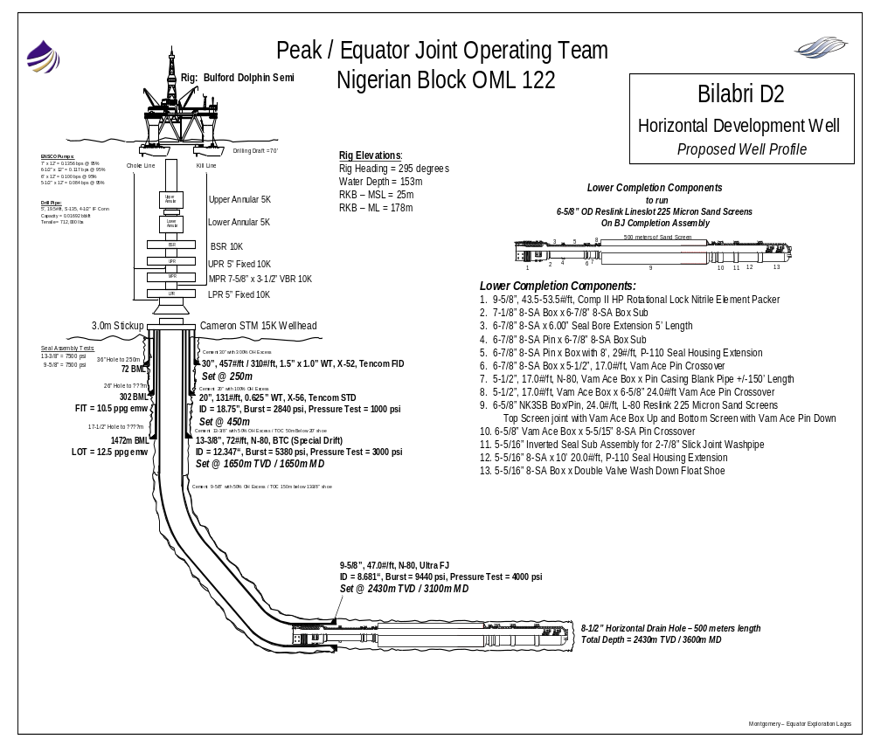

APPENDIX 4 BJ

DST #1: BJ 6 5/8” Open Hole Screens Test String Components

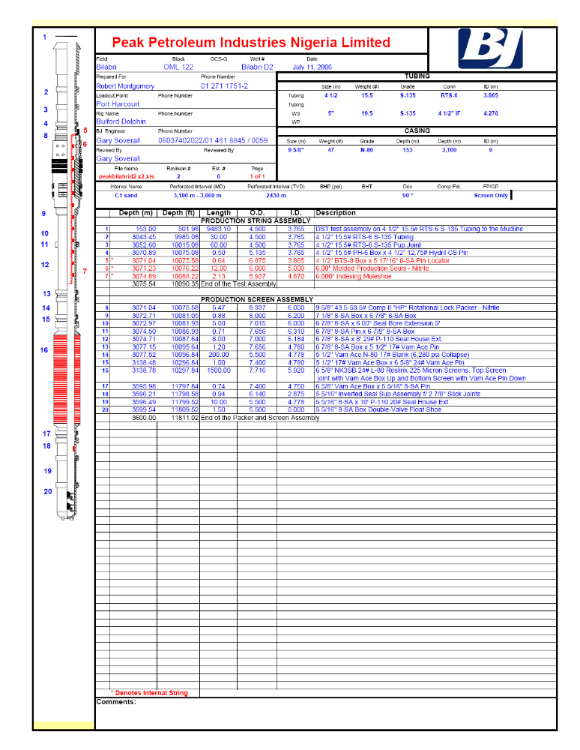

APPENDIX 5

Halliburton

DST #9 5/8” Casing Test String Components

APPENDIX 6

Powerwell Landing String Diagram

DRAFT – NEW SCHEMATIC TO BE SUPPLIED

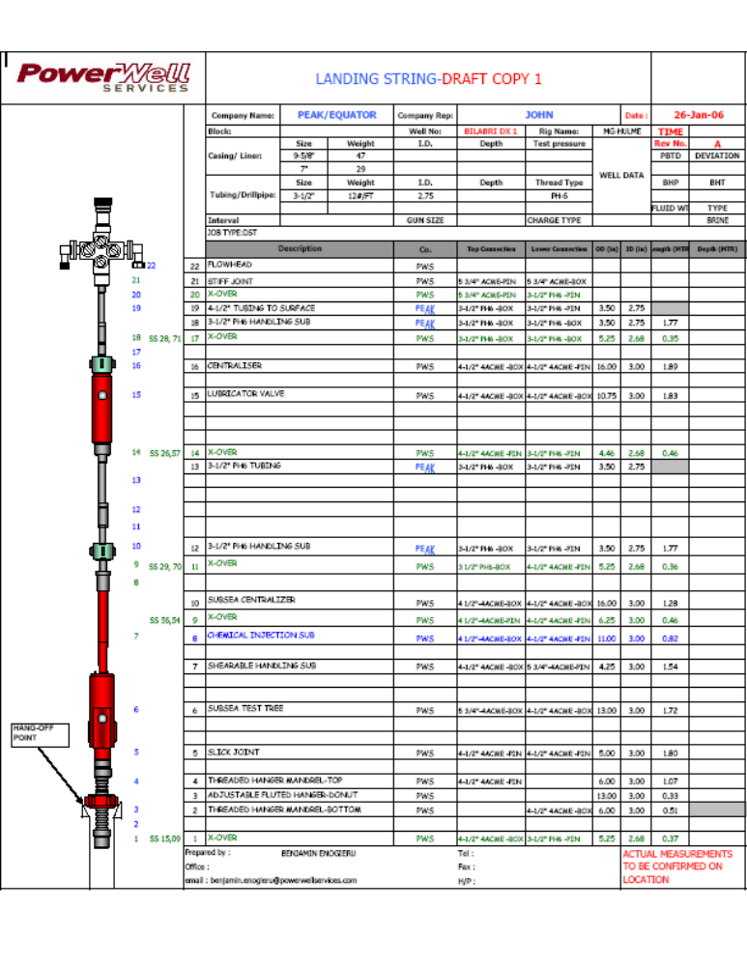

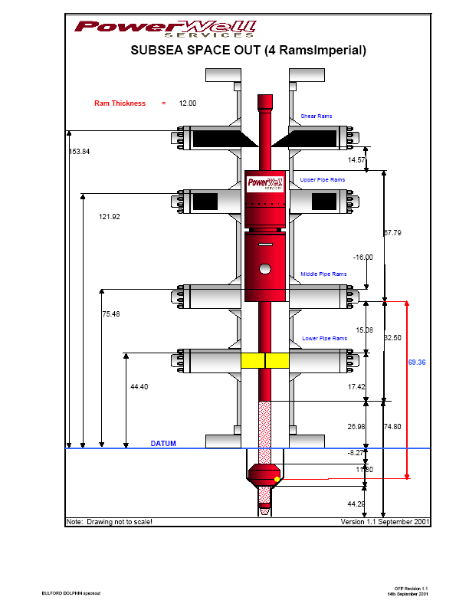APPENDIX 7 Bulford Dolphin SS BOP Stack Layout

APPENDIX 8

Powerwell Surface Test Spread
